Home Work 4  
Data Ware House

Checking the count of Tables:

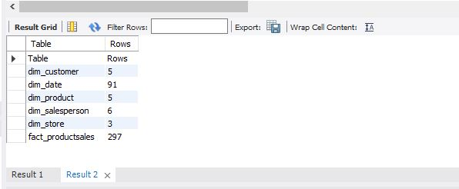

Query 1

select a.CustomerName, a.Gender, d.SalesPersonName, d.City

from dim_customer as a join fact_productsales as b

on a.CustomerID=b.CustomerID join dim_date as c on

b.SalesDateKey=c.DateKey join dim_salesperson as d

on b.SalesPersonID = d.SalesPersonID

where c.YEAR = "2015" and c.MONTH = "9"

and b.SalesPrice > 20 and b.Quantity > 8

group by b.ProductID

;

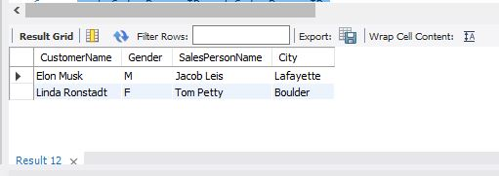

Query 2

select a.StoreName , a.City , c.ProductName

from dim_store as a join fact_productsales as b on

a.StoreID = b.StoreID join dim_product as c on

b.ProductID = c.ProductKey join dim_date as d on

b.SalesDateKey = d.DateKey

where d.MONTH = "3" and d.YEAR= "2017"

and a.City="Boulder" and b.ProductCost < 50

;

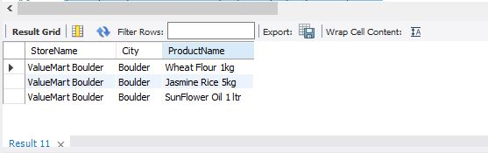

Query 3:

select a.SalesPersonID , a.SalesPersonName , (sum(b.ProductCost) * sum(c.ProductSalesPrice)) as total_Revenue

from dim_salesperson as a join fact_productsales as b on

a.SalesPersonID = b.SalesPersonID join dim_product as c on

b.ProductID = c.ProductKey join dim_date as d on

b.SalesDateKey = d.DateKey

where d.YEAR = "2017"

order by total_Revenue desc

limit 2

;

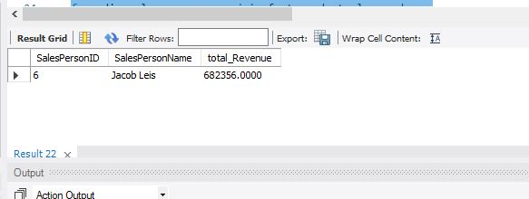

Query 4:

select a.CustomerName , sum(b.SalesPrice * b.Quantity) as Lowest_Total_Revenue

from dim_customer as a join fact_productsales as b on

a.CustomerID = b.CustomerID join dim_date as c on

b.SalesDateKey = c.DateKey

where c.Year = "2017"

group by a.CustomerName

order by Lowest_Total_Revenue asc

limit 1

;

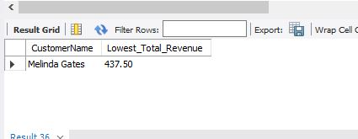

Query 5:

select a.StoreName , sum(b.SalesPrice) as total_sales_Price

from dim_store as a join fact_productsales as b on

a.StoreID = b.StoreID join dim_date as c on

b.SalesDateKey = c.DateKey

where c.YEAR >= "2010" and c.YEAR <= "2017"

group by a.StoreName

order by a.StoreName asc

;

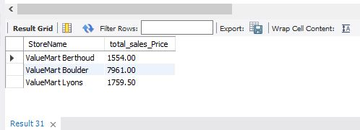

Query 6:

select a.StoreName, c.ProductName , (b.SalesPrice * b.Quantity) - (b.ProductCost * b.Quantity) as profit

from dim_store as a join fact_productsales as b on

a.StoreID = b.StoreID join dim_product as c on

c.ProductKey = b.ProductID join dim_date as d on

b.SalesDateKey = d.DateKey

where c.ProductName="Jasmine Rice 5kg" and d.YEAR="2010"

;

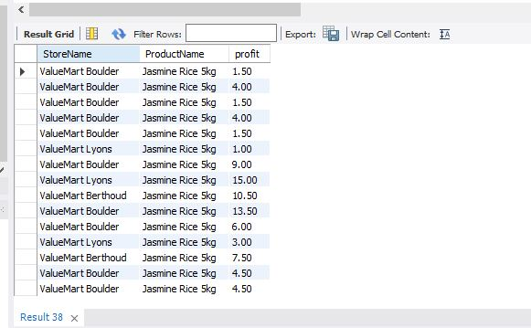

Query 7:

select a.StoreName,c.QUARTER,c.YEAR , (b.SalesPrice * b.Quantity) as Total_Revenue

from dim_store as a join fact_productsales as b on

a.StoreID = b.StoreID join dim_date as c on

c.DateKey = b.SalesDateKey

where c.YEAR="2016" and a.StoreName="ValueMart Boulder"

group by c.QUARTER

order by c.QUARTER

;

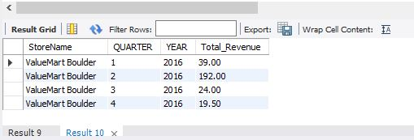

Query 8:

select a.CustomerName , sum(b.SalesPrice) as Total_sales_price

from dim_customer as a join fact_productsales as b on

a.CustomerID = b.CustomerID

where a.CustomerName="Melinda Gates" or a.CustomerName="Harrison Ford"

group by a.CustomerName

;

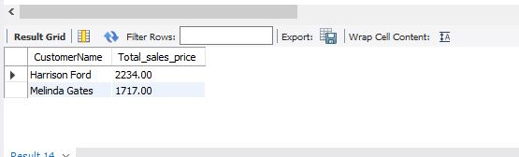

Query 9:

select a.StoreName,b.SalesPrice,d.CustomerName

from dim_store as a join fact_productsales as b on

a.StoreID=b.StoreID join dim_date as c on

b.SalesDateKey = c.DateKey join dim_customer as d on

b.customerId = d.customerId

where c.DAYOFMONTH="12" and c.MONTH="3" and c.YEAR="2017"

;

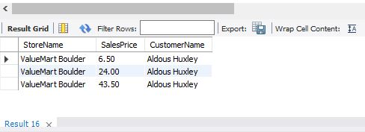

Query 10:

select a.SalesPersonName,sum(b.SalesPrice*b.Quantity) as Highest_Revenue

from dim_salesperson as a join fact_productsales as b on

a.SalesPersonID=b.SalesPersonID

group by a.SalesPersonName

order by Highest_Revenue desc

limit 1

;

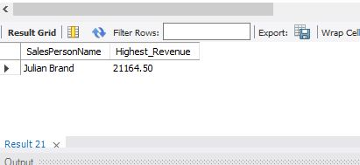

Query 11:

select a.ProductName, (b.SalesPrice * b.Quantity) - (b.ProductCost * b.Quantity) as profit

from dim_product as a join fact_productsales as b on

a.ProductKey = b.ProductID

group by ProductName

order by profit desc

limit 1

;

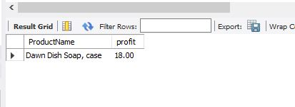

Query 12:

select a.YEAR,a.MONTH, sum(b.SalesPrice * b.Quantity) as Revenue

from dim_date as a join fact_productsales as b on

a.DateKey = b.SalesDateKey

where (a.MONTH='1' or a.MONTH='2' or a.MONTH='3') and a.YEAR="2017"

group by a.MONTH

;

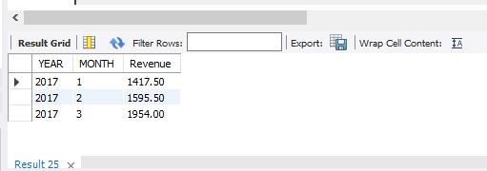

Query 13:

select a.ProductName , round(AVG(b.ProductCost),2) as Average_Product_cost , round(AVG(b.SalesPrice),2) as Average_sales_price

from dim_product as a join fact_productsales as b on

a.ProductKey = b.ProductID join dim_date as c on

b.SalesDateKey = c.DateKey

where c.YEAR = "2017"

group by a.ProductName

;

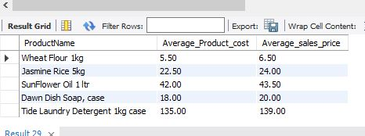

Query 14:

select a.CustomerName, round(avg(b.SalesPrice),2) as average_sales_price , round(avg(b.Quantity),2) as average_Quantity

from dim_customer as a join fact_productsales as b on

a.CustomerID = b.CustomerID

where a.CustomerName="Melinda Gates"

group by a.CustomerName

;

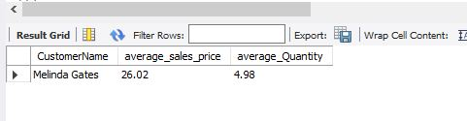

Query 15:

select a.City , Max(b.SalesPrice) as Maximum_sales_price , Min(b.SalesPrice) as Minimum_sales_price

from dim_store as a join fact_productsales as b on

a.StoreID = b.StoreID

where a.City = "Boulder"

group by a.City

;

